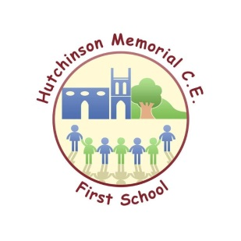
Hutchinson Memorial CE First School – Nursery Sessions Booking Form
Name of Child: ________________________ Date of Birth: ___________
I wish to apply for a nursery place starting ______________________________ (Date).
I wish to apply for the following sessions (please tick):
 | Morning session  8.45am to 11.30am | Lunch  11.30am to 12.30pm | Afternoon session  12.30pm to 3.15pm | School meal  £2.50 per day | Packed lunch to be provided (Please tick if applicable).
Monday
Tuesday
Wednesday
Thursday
Friday

- For all sessions- please use 15/ 30 hrs funded then pay the additional required.
These sessions are chargeable as follows:
- Nursery Education Funding (currently 15 hours per week maximum)
- Extended Funding to 30 hours (if eligible).
- Any hours in excess of the funded hours will be charged at £4 per hour.

Charges are payable half termly unless we receive prior notice of any changes. Refunds will not be given for non-attendance at pre booked sessions. Meals not taken will be refunded.
I confirm that I have read and agree to the Terms & Conditions of the Nursery Policy for Hutchinson Memorial CE First School. I accept that the session times requested are not guaranteed until confirmation is received in writing from the school.

Signed_____________________________________________ Date_________________
(Person with parental responsibility)
Please return to the school office: Hutchinson Memorial CE First School, Uttoxeter Road, Checkley, Stoke on Trent ST10 4NB or email: office@hutchinson.staffs.sch.uk

