Summer 2 2023 Curriculum Overview
Our final term is here and already flying by. We started the term with our focus text ‘Sunk!’ all about Penguin Blue going on a pirate adventure. We have been completing lots of fun, pirate themed activities in the classroom. Over the next few weeks, we will be taking part in our whole school sports day.
Please continue to check Seesaw and school bags regularly for any notices.

Reminder of items needed in school each day please:
- named water bottle filled with water only please
- suitable coat if required
- sunhat or cap
Please ensure sun protection is applied in the morning before school. Thank you

Activities for home
Thank you for completing any activities sent home with your child or set on Seesaw. These activities consolidate our learning in school and give the children the opportunity to share their learning at home. Please continue to support your child with these each week. Thank you.

Reading in Owls
Thank you for support in helping your child on their reading journey. Please read their decodable reading book several times throughout the week to help the children develop their confidence in blending and then reading words by sight. Reading books will be changed on a Monday.
Well done to all our Nursery children for sharing their chosen story book at home. We hope you enjoy this special time where you can talk about the pictures and what you like about the story.

Phonics
We are continuing to progress through Level 4. Please practise the tricky words sent home as regularly as you can. Encourage your child to also write the words using the correct letter formation. Please refer to the Twinkl Letter Mat for the letter formation we are teaching in Reception. Thank you.

Keeping in touch
Please do not hesitate to contact us if you have questions, queries or just need to update us with things that may happen away from school. You can a message us through Seesaw or email through the office office@hutchinson.staffs.sch.uk We will get back to you as soon as we can either with a message or phone call if required.
Mrs Owen & Miss Johnson

Summer 2 – Curriculum Information
Topic  Let’s Travel | Focus texts  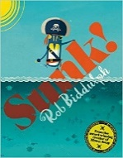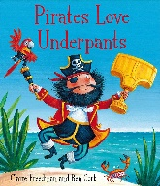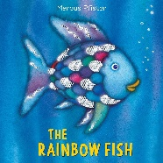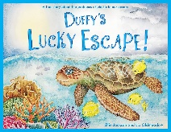 | Rationale  We are using our Pirate theme to discover different countries around the world. In doing so. we will explore under the sea and learn about the importance of looking after our environment.
Communication and Language | We will listen to and retell different stories learning new vocabulary. We will talk about past events as we share things we have enjoyed over the year.
Personal, Social and Emotional | This half term we will be:  - Making healthy choices about what we eat.  - Developing our own independence as we select our own resources.  - Talking about our own work and things we have done well.  - Working with a partner to complete class activities respecting each other’s ideas.
RHE | Theme – Keeping Safe in the Summer.
Physical | This term we will be developing our use of one-handed tools in the classroom. We will chop fruit to make smoothies and make our own sandwiches. We will be practising our writing, making sure all our letters are formed correctly.  In PE, we will:  - Develop our co-operation and problem-solving skills  - Practising in preparation for our Sports’ Afternoon
Literacy | Nursery will be making their own marks and beginning to give meaning to them. We will be retelling stories and beginning to learn some letter sounds. We will be learning how to write all the letters in our name.  Reception will be learning new sounds during our daily phonics’ sessions. We will be writing our own sentences applying sounds we have learnt in phonics. We will be using our phonic knowledge to read short sentences, reading some words by sight.
Mathematics | Nursery will complete lots of practical activities using numbers. We will be learning:  - How to sequence events in our day  - Capacity  - Using positional language.  Reception will follow the White Rose Maths Scheme. We will be adding amounts and taking away. We will share different amounts talking about how we share fairly. We will also be learning how we can create different shapes through lots of practical activities. We will continue our quick recall of number bonds to 5 and 10.
Understanding the World | This half term we will be:  - Learning about floating and sinking. What material makes the best boat for a pirate?  - Comparing different countries and learn about the similarities and differences between them. We will locate them on the globe and make comparisons to our country.  - Noticing the changes in the environment during Summer.  - Learning about the importance of recycling and looking after our animals.  - Talking about past events in our own lives.
Expressive Arts and Design | This half term we will be:  - Creating our own Summer pictures selecting different resources.  - Drawing and painting pirates with increasing accuracy.  - Taking on roles in our pirate role play.  - Using different materials to make a new friend for the Rainbow Fish.  - Learning new songs to perform at the end of term.
RE | Nursery ‘Special Words’  Reception ‘What makes every person special and unique?’

Some activities for your child to try at home….
Help write a shopping list.  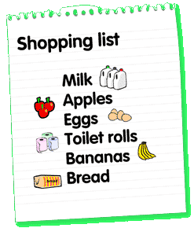 | Make your own treasure map and hide the treasure.  . 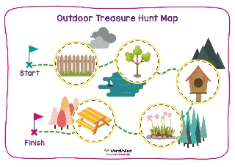
Help make some sandwiches for a picnic.  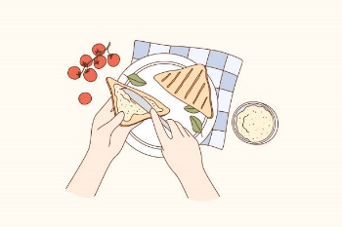 | Play games and take turns.  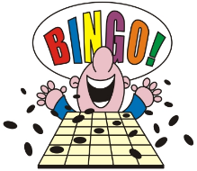

Useful websites
https://www.phonicsplay.co.uk/ - for fun phonics games
https://www.topmarks.co.uk/maths-games/5-7-years/counting - for fun maths activities
https://www.bbc.co.uk/iplayer/episodes/b08bzfnh/numberblocks - to consolidate our work in Early number
https://whitrosemaths.com/1-minute-maths - quick activities to consolidate Maths activities.
https://www.bbc.co.uk/iplayer/episodes/b08bzfnh/numberblocks - a fun way to explore Number

